**9.PROGRAM TO USE WHILE LOOP ,DO WHILE LOOP**

**WHILE LOOP:**

// Print numbers from 1 to 5

#include <stdio.h>

int main()

{

int i = 1;

while (i <= 5)

{

printf("%d\n", i);

++i;

}

return 0;

}

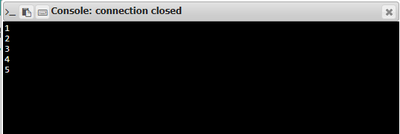

**DO WHILE LOOP:**

**// Program to add numbers until the user enters zero**

#include <stdio.h>

int main()

{

double number, sum = 0;

// the body of the loop is executed at least once

do

{

printf("Enter a number: ");

scanf("%lf", &number);

sum += number;

}

while(number != 0.0);

printf("Sum = %.2lf",sum);

return 0;

}

